

**Course Notes**

|  |  |
| --- | --- |
| **Course Name** | **Quranic Connection** |
| **Lesson #** | **3** |
| **Info** | **Surat-al-Ikhlas**  **Surat-al-Falaq**  **Surat-an-Naas** |

**[](https://www.seekingreward.org/)   [](http://www.facebook.com/seekingrewardfoundation)   [](http://www.instagram.com/seekingreward)   [](http://www.twitter.com/seekingreward)   [](http://www.youtube.com/seekingreward)**

**www.seekingreward.org**

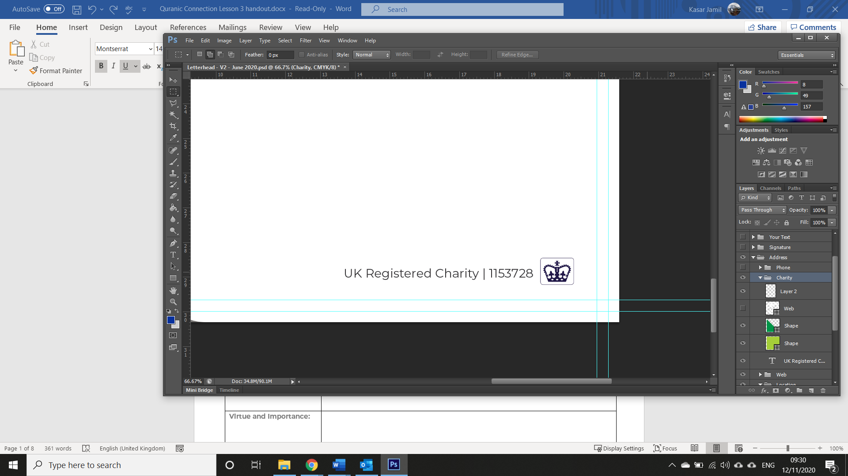

**Surat-al-Ikhlas**

|  |  |
| --- | --- |
| **Place of Revelation:** |  |
| **Reason for Revelation:** |  |
| **Virtue and Importance:** |  |
| **Any specific ruling(s):** |  |

|  |  |
| --- | --- |
| **Ayat 1:** | قُلۡ هُوَ ٱللَّهُ أَحَدٌ |
| **Interpretation of the Meaning:** | Say, "He is Allah, [who is] One, |
| **Significance:** |  |
| **Additional Notes:** |  |

|  |  |
| --- | --- |
| **Ayat 2:** | ٱللَّهُ ٱلصَّمَدُ |
| **Interpretation of the Meaning:** | Allah, the Eternal Refuge. |
| **Significance:** |  |
| **Additional Notes:** |  |

|  |  |
| --- | --- |
| **Ayat 3:** | لَمۡ يَلِدۡ وَلَمۡ يُولَدۡ |
| **Interpretation of the Meaning:** | He neither begets nor is born, |
| **Significance:** |  |
| **Additional Notes:** |  |

|  |  |
| --- | --- |
| **Ayat 4:** | وَلَمۡ يَكُن لَّهُۥ كُفُوًا أَحَدُۢ |
| **Interpretation of the Meaning:** | Nor is there to Him any equivalent." |
| **Significance:** |  |
| **Additional Notes:** |  |

|  |
| --- |
| **Additional Notes:** |

**Surat-al-Falaq**

|  |  |
| --- | --- |
| **Place of Revelation:** |  |
| **Reason for Revelation:** |  |
| **Virtue and Importance:** |  |
| **Any specific ruling(s):** |  |

|  |  |
| --- | --- |
| **Ayat 1** | قُلۡ أَعُوذُ بِرَبِّ ٱلۡفَلَقِ |
| **Interpretation of the Meaning:** | Say, "I seek refuge in the Lord of daybreak |
| **Significance:** |  |
| **Additional Notes:** |  |

|  |  |
| --- | --- |
| **Ayat 2** | مِن شَرِّ مَا خَلَقَ |
| **Interpretation of the Meaning:** | From the evil of that which He created |
| **Significance:** |  |
| **Additional Notes:** |  |

|  |  |
| --- | --- |
| **Ayat 3** | وَمِن شَرِّ غَاسِقٍ إِذَا وَقَبَ |
| **Interpretation of the Meaning:** | And from the evil of darkness when it settles |
| **Significance:** |  |
| **Additional Notes:** |  |

|  |  |
| --- | --- |
| **Ayat 4** | وَمِن شَرِّ ٱلنَّفَّـٰثَٰتِ فِي ٱلۡعُقَدِ |
| **Interpretation of the Meaning:** | And from the evil of the blowers in knots |
| **Significance:** |  |
| **Additional Notes:** |  |

|  |  |
| --- | --- |
| **Ayat 5** | وَمِن شَرِّ حَاسِدٍ إِذَا حَسَدَ |
| **Interpretation of the Meaning:** | And from the evil of an envier when he envies." |
| **Significance:** |  |
| **Additional Notes:** |  |

|  |
| --- |
| **Additional Notes:** |

**Surat-an-Nas**

|  |  |
| --- | --- |
| **Place of Revelation:** |  |
| **Reason for Revelation:** |  |
| **Virtue and Importance:** |  |
| **Any specific ruling(s):** |  |

|  |  |
| --- | --- |
| **Ayat 1** | قُلۡ أَعُوذُ بِرَبِّ ٱلنَّاسِ |
| **Interpretation of the Meaning:** | Say, "I seek refuge in the Lord of mankind, |
| **Significance:** |  |
| **Additional Notes:** |  |

|  |  |
| --- | --- |
| **Ayat 2** | مَلِكِ ٱلنَّاسِ |
| **Interpretation of the Meaning:** | The Sovereign of mankind. |
| **Significance:** |  |
| **Additional Notes:** |  |

|  |  |
| --- | --- |
| **Ayat 3** | إِلَٰهِ ٱلنَّاسِ |
| **Interpretation of the Meaning:** | The God of mankind, |
| **Significance:** |  |
| **Additional Notes:** |  |

|  |  |
| --- | --- |
| **Ayat 4** | مِن شَرِّ ٱلۡوَسۡوَاسِ ٱلۡخَنَّاسِ |
| **Interpretation of the Meaning:** | From the evil of the retreating whisperer - |
| **Significance:** |  |
| **Additional Notes:** |  |

|  |  |
| --- | --- |
| **Ayat 5** | ٱلَّذِي يُوَسۡوِسُ فِي صُدُورِ ٱلنَّاسِ |
| **Interpretation of the Meaning:** | Who whispers [evil] into the breasts of mankind - |
| **Significance:** |  |
| **Additional Notes:** |  |

|  |  |
| --- | --- |
| **Ayat 6** | مِنَ ٱلۡجِنَّةِ وَٱلنَّاسِ |
| **Interpretation of the Meaning:** | From among the jinn and mankind." |
| **Significance:** |  |
| **Additional Notes:** |  |

|  |
| --- |
| **Additional Notes:** |