

**Course Notes**

|  |  |
| --- | --- |
| **Course Name** | **Quranic Connection** |
| **Lesson #** | **4** |
| **Info** | **Surat-al-Kafirun**  **Surat-an-Nasr**  **Surat-al-Masad** |

**[](https://www.seekingreward.org/)   [](http://www.facebook.com/seekingrewardfoundation)   [](http://www.instagram.com/seekingreward)   [](http://www.twitter.com/seekingreward)   [](http://www.youtube.com/seekingreward)**

**www.seekingreward.org**

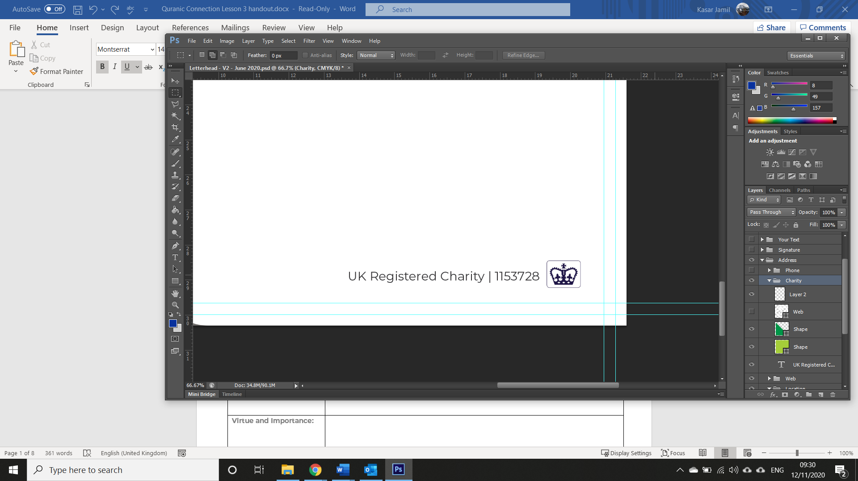

**Surat-** **al-Kafirun**

|  |  |
| --- | --- |
| **Place of Revelation:** |  |
| **Reason for Revelation:** |  |
| **Virtue and Importance:** |  |
| **Any specific ruling(s):** |  |

|  |  |
| --- | --- |
| **Ayat 1:** | قُلْ يَا أَيُّهَا الْكَافِرُونَ |
| **Interpretation of the Meaning:** | Say, "O disbelievers, |
| **Significance:** |  |
| **Additional Notes:** |  |

|  |  |
| --- | --- |
| **Ayat 2:** | لَا أَعْبُدُ مَا تَعْبُدُونَ |
| **Interpretation of the Meaning:** | I do not worship what you worship. |
| **Significance:** |  |
| **Additional Notes:** |  |

|  |  |
| --- | --- |
| **Ayat 3:** | وَلَا أَنْتُمْ عَابِدُونَ مَا أَعْبُدُ |
| **Interpretation of the Meaning:** | Nor are you worshippers of what I worship. |
| **Significance:** |  |
| **Additional Notes:** |  |

|  |  |
| --- | --- |
| **Ayat 4:** | وَلَا أَنَا عَابِدٌ مَا عَبَدْتُمْ |
| **Interpretation of the Meaning:** | Nor will I be a worshipper of what you worship. |
| **Significance:** |  |
| **Additional Notes:** |  |

|  |  |
| --- | --- |
| **Ayat 5:** | وَلَا أَنْتُمْ عَابِدُونَ مَا أَعْبُدُ |
| **Interpretation of the Meaning:** | Nor will you be worshippers of what I worship. |
| **Significance:** |  |
| **Additional Notes:** |  |

|  |  |
| --- | --- |
| **Ayat 6:** | لَكُمْ دِينُكُمْ وَلِيَ دِينِ |
| **Interpretation of the Meaning:** | For you is your religion, and for me is my religion." |
| **Significance:** |  |
| **Additional Notes:** |  |

|  |
| --- |
| **Additional Notes:** |

**Surat-** **an-Nasr**

|  |  |
| --- | --- |
| **Place of Revelation:** |  |
| **Reason for Revelation:** |  |
| **Virtue and Importance:** |  |
| **Any specific ruling(s):** |  |

|  |  |
| --- | --- |
| **Ayat 1** | إِذَا جَاءَ نَصْرُ اللَّهِ وَالْفَتْحُ |
| **Interpretation of the Meaning:** | When the victory of Allah has come and the conquest, |
| **Significance:** |  |
| **Additional Notes:** |  |

|  |  |
| --- | --- |
| **Ayat 2** | وَرَأَيْتَ النَّاسَ يَدْخُلُونَ فِي دِينِ اللَّهِ أَفْوَاجًا |
| **Interpretation of the Meaning:** | And you see the people entering into the religion of Allah in multitudes, |
| **Significance:** |  |
| **Additional Notes:** |  |

|  |  |
| --- | --- |
| **Ayat 3** | فَسَبِّحْ بِحَمْدِ رَبِّكَ وَاسْتَغْفِرْهُ ۚ إِنَّهُ كَانَ تَوَّابًا |
| **Interpretation of the Meaning:** | Then exalt [Him] with praise of your Lord and ask forgiveness of Him. Indeed, He is ever Accepting of Repentance. |
| **Significance:** |  |
| **Additional Notes:** |  |

|  |
| --- |
| **Additional Notes:** |

**Surat-** **al-Masad**

|  |  |
| --- | --- |
| **Place of Revelation:** |  |
| **Reason for Revelation:** |  |
| **Virtue and Importance:** |  |
| **Any specific ruling(s):** |  |

|  |  |
| --- | --- |
| **Ayat 1** | تَبَّتْ يَدَا أَبِي لَهَبٍ وَتَبَّ |
| **Interpretation of the Meaning:** | Say, "I seek refuge in the Lord of mankind, |
| **Significance:** |  |
| **Additional Notes:** |  |

|  |  |
| --- | --- |
| **Ayat 2** | مَا أَغْنَىٰ عَنْهُ مَالُهُ وَمَا كَسَبَ |
| **Interpretation of the Meaning:** | The Sovereign of mankind. |
| **Significance:** |  |
| **Additional Notes:** |  |

|  |  |
| --- | --- |
| **Ayat 3** | سَيَصْلَىٰ نَارًا ذَاتَ لَهَبٍ |
| **Interpretation of the Meaning:** | The God of mankind, |
| **Significance:** |  |
| **Additional Notes:** |  |

|  |  |
| --- | --- |
| **Ayat 4** | وَامْرَأَتُهُ حَمَّالَةَ الْحَطَبِ |
| **Interpretation of the Meaning:** | From the evil of the retreating whisperer - |
| **Significance:** |  |
| **Additional Notes:** |  |

|  |  |
| --- | --- |
| **Ayat 5** | فِي جِيدِهَا حَبْلٌ مِنْ مَسَدٍ |
| **Interpretation of the Meaning:** | Who whispers [evil] into the breasts of mankind - |
| **Significance:** |  |
| **Additional Notes:** |  |

|  |
| --- |
| **Additional Notes:** |