

**Course Notes**

|  |  |
| --- | --- |
| **Course Name** | **Quranic Connection** |
| **Lesson #** | **5** |
| **Info** | **Surat-Quraysh**  **Surat-al-Ma’un**  **Surat-al-Kauthar** |

**[](https://www.seekingreward.org/)   [](http://www.facebook.com/seekingrewardfoundation)   [](http://www.instagram.com/seekingreward)   [](http://www.twitter.com/seekingreward)   [](http://www.youtube.com/seekingreward)**

**www.seekingreward.org**

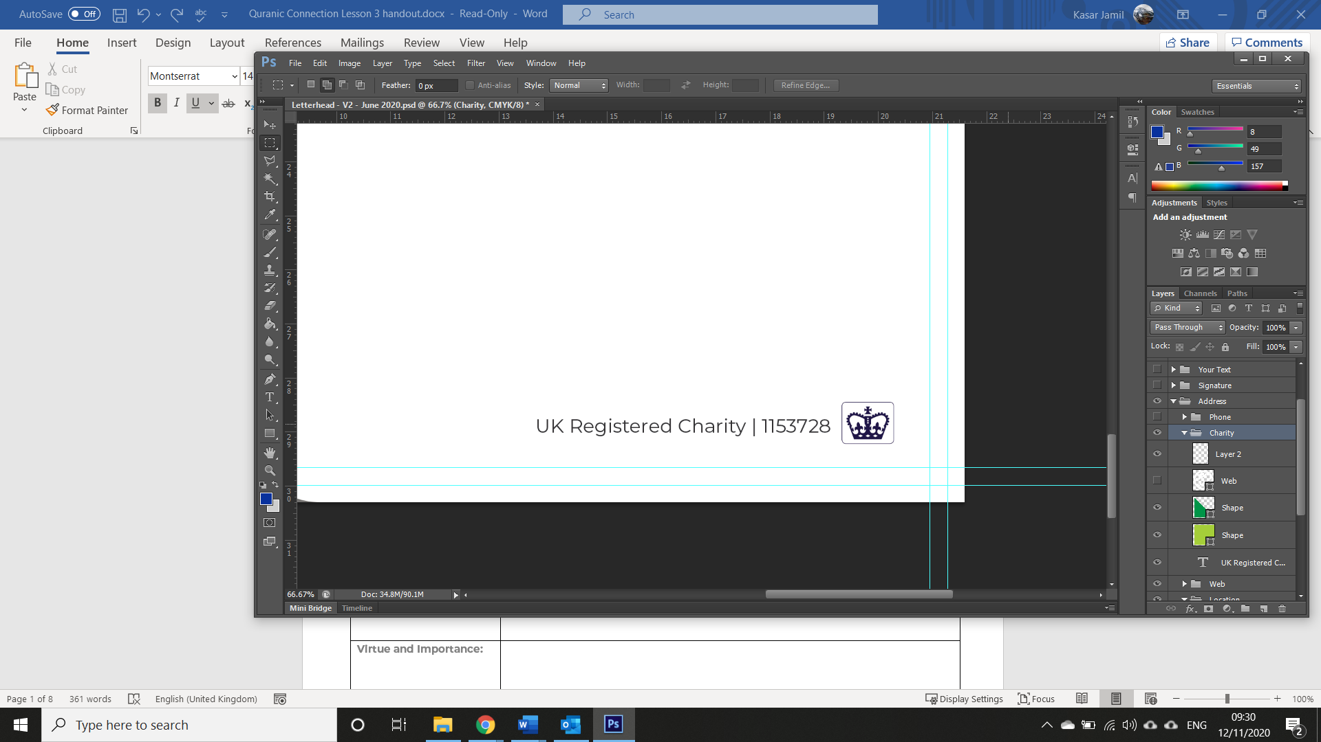

**Surat-** **Quraysh**

|  |  |
| --- | --- |
| **Place of Revelation:** |  |
| **Reason for Revelation:** |  |
| **Virtue and Importance:** |  |
| **Any specific ruling(s):** |  |

|  |  |
| --- | --- |
| **Ayat 1:** | لِإِيلَافِ قُرَيْشٍ |
| **Interpretation of the Meaning:** | For the accustomed security of the Quraysh |
| **Significance:** |  |
| **Additional Notes:** |  |

|  |  |
| --- | --- |
| **Ayat 2:** | إِيلَافِهِمْ رِحْلَةَ الشِّتَاءِ وَالصَّيْفِ |
| **Interpretation of the Meaning:** | Their accustomed security [in] the caravan of winter and summer |
| **Significance:** |  |
| **Additional Notes:** |  |

|  |  |
| --- | --- |
| **Ayat 3:** | فَلْيَعْبُدُوا رَبَّ هَٰذَا الْبَيْتِ |
| **Interpretation of the Meaning:** | Let them worship the Lord of this House |
| **Significance:** |  |
| **Additional Notes:** |  |

|  |  |
| --- | --- |
| **Ayat 4:** | الَّذِي أَطْعَمَهُمْ مِنْ جُوعٍ وَآمَنَهُمْ مِنْ خَوْفٍ |
| **Interpretation of the Meaning:** | Who has fed them, [saving them] from hunger and made them safe, [saving them] from fear. |
| **Significance:** |  |
| **Additional Notes:** |  |

|  |
| --- |
| **Additional Notes:** |

**Surat-** **al-Ma’un**

|  |  |
| --- | --- |
| **Place of Revelation:** |  |
| **Reason for Revelation:** |  |
| **Virtue and Importance:** |  |
| **Any specific ruling(s):** |  |

|  |  |
| --- | --- |
| **Ayat 1** | أَرَأَيْتَ الَّذِي يُكَذِّبُ بِالدِّينِ |
| **Interpretation of the Meaning:** | Have you seen the one who denies the Recompense? |
| **Significance:** |  |
| **Additional Notes:** |  |

|  |  |
| --- | --- |
| **Ayat 2** | فَذَٰلِكَ الَّذِي يَدُعُّ الْيَتِيمَ |
| **Interpretation of the Meaning:** | For that is the one who drives away the orphan |
| **Significance:** |  |
| **Additional Notes:** |  |

|  |  |
| --- | --- |
| **Ayat 3** | وَلَا يَحُضُّ عَلَىٰ طَعَامِ الْمِسْكِينِ |
| **Interpretation of the Meaning:** | And does not encourage the feeding of the poor. |
| **Significance:** |  |
| **Additional Notes:** |  |

|  |  |
| --- | --- |
| **Ayat 4** | فَوَيْلٌ لِلْمُصَلِّينَ |
| **Interpretation of the Meaning:** | So woe to those who pray |
| **Significance:** |  |
| **Additional Notes:** |  |

|  |  |
| --- | --- |
| **Ayat 5** | الَّذِينَ هُمْ عَنْ صَلَاتِهِمْ سَاهُونَ |
| **Interpretation of the Meaning:** | [But] who are heedless of their prayer |
| **Significance:** |  |
| **Additional Notes:** |  |

|  |  |
| --- | --- |
| **Ayat 6** | الَّذِينَ هُمْ يُرَاءُونَ |
| **Interpretation of the Meaning:** | Those who make show [of their deeds] |
| **Significance:** |  |
| **Additional Notes:** |  |

|  |  |
| --- | --- |
| **Ayat 7** | وَيَمْنَعُونَ الْمَاعُونَ |
| **Interpretation of the Meaning:** | And withhold [simple] assistance. |
| **Significance:** |  |
| **Additional Notes:** |  |

|  |
| --- |
| **Additional Notes:** |

**Surat-** **al-Kauthar**

|  |  |
| --- | --- |
| **Place of Revelation:** |  |
| **Reason for Revelation:** |  |
| **Virtue and Importance:** |  |
| **Any specific ruling(s):** |  |

|  |  |
| --- | --- |
| **Ayat 1** | إِنَّا أَعْطَيْنَاكَ الْكَوْثَرَ |
| **Interpretation of the Meaning:** | Indeed, We have granted you, [O Muḥammad], al-Kawthar. |
| **Significance:** |  |
| **Additional Notes:** |  |

|  |  |
| --- | --- |
| **Ayat 2** | فَصَلِّ لِرَبِّكَ وَانْحَرْ |
| **Interpretation of the Meaning:** | So pray to your Lord and offer sacrifice [to Him alone]. |
| **Significance:** |  |
| **Additional Notes:** |  |

|  |  |
| --- | --- |
| **Ayat 3** | إِنَّ شَانِئَكَ هُوَ الْأَبْتَرُ |
| **Interpretation of the Meaning:** | Indeed, your enemy is the one cut off. |
| **Significance:** |  |
| **Additional Notes:** |  |

|  |
| --- |
| **Additional Notes:** |